Assignment-10 EEC-3150 Engineering Programming II
- In the Blackboard Resources is a LinkedIn Learning course entitled Python Essential Training.

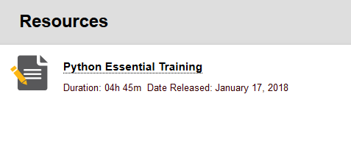
Review any lessons from the following chapters to increase your understanding:
Chapter 15 Databases

You may choose any of the videos, or all of the videos that will increase your knowledge of the Python programming language. You are to enumerate three learnings from the videos you have selected. Each of the three learnings should be described in one or two sentences.

- In this exercise you will use the "Class Rational(object)" created in Assignment-9. We will be calculating the successive terms of a geometric series. The Wikipedia article entitled "Geometric Series": https://en.wikipedia.org/wiki/Geometric_series defines this (also see Appendix).

The user will input three values:
- The starting term, a (can use the form n/d for easy conversion to Rational numbers)
- The common ratio, r (can use the form n/d for easy conversion to Rational numbers)
- The number of terms of the series to be displayed, n (a simple integer > 0)

Example:
Enter the starting term of the form numerator/denominator: 9/1
Enter the common ratio of the form numerator/denominator: 1/3
Enter the number of terms of the geometric series: 5

The geometric series:
9/1
3/1
1/1
1/3
1/9
Submit: A file called Assignment-10-Results.docx to Blackboard.
Appendix
